* Input a text in the console.
* Check if the text contains only sorted digits (from lowest to highest values)
* If so, write SORTED, otherwise write NOT SORTED

1. What will be the **result** for these outputs?

|  |  |
| --- | --- |
| **Input** | **Output** |
| 489 | SORTED |
| 4762 | NOT SORTED |
| 12 | SORTED |
| 1268 |  |
| 1896 |  |
| 1536 |  |
| 2789 |  |

1. How many parts can you divide the problem into? Individual work.

text=input()

result=""

for i in range(len(text)):

    if text[0]<text[i] or text[0]==text[i]:

        result="SORTED"

    elif text[0]>text[i]:

        result="NOT SORTED"

print(result)

1. Create the flowchart structure of your algorithm. Team (3 students) work.
2. Implement your code. Team (3 students) work.
3. Execute it in a table of execution. Team (3 students) work.

* Input a text in the console.
* Control that the text is owning only "abc" pattern.
  + Print “OK” if so
  + Otherwise, print “WRONG”

1. What will be the **result** for these outputs?

|  |  |
| --- | --- |
| **Input** | **Output** |
| abcd | WRONG |
| abcabc | OK |
| abc | OK |
| aabc |  |
| abbc |  |
| abcabcab |  |
| abcdefg |  |

1. Create your flowchart structure with black boxes.

* Each student has to create his own.
* Share the result in group of 3.

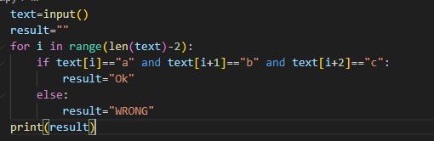

1. Implement it in Python. In group of 3.
2. Fill up the execution table. In group of 3.

|  |  |  |  |
| --- | --- | --- | --- |
| Step | Variable 1 | Variable 2 | Variable 3 |
| 1 |  |  |  |
| 2 |  |  |  |
| … |  |  |  |

1. Present your flowchart structure to the class. In group of 3.

* Input a text in the console.
* Check that the text:
  + Has only *y*, between square brackets (need open AND close brackets).
  + Otherwise has *x*
* If the text is correct
  + Print “OK”
  + Otherwise, print “WRONG”

1. What will be the **result** for these outputs? Individual work

|  |  |
| --- | --- |
| **Input** | **Output** |
| xxx[yyy]xxx | Ok |
| [yyy]xxx | OK |
| xxx[yyy | WRONG |
| xxxy |  |
| [yy] |  |
| xxx[yxyy]xxx |  |
| xxxxx |  |

1. Which main instruction can solve the problem? What will it be used for? Group of 3 students.

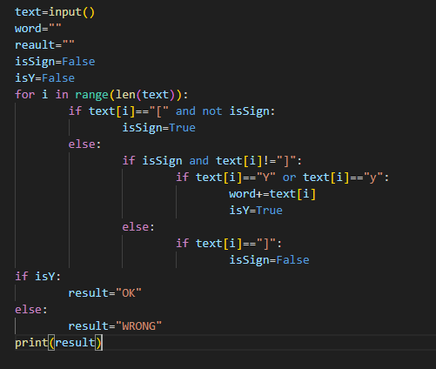

1. Create a code to solve this problem. Group of 3 students.
2. Present your solution to the class. Group of 3 students.